Distributive Adjectives

🔹 What Are Distributive Adjectives?
# Source: AI Source: Provided by: [Data Path: Persons Table -> ID Column: 1, Name_En Column: Motasem Essam] -> From: [Chatgpt (GPT-4-turbo)] on [7/27/2025]
Distributive adjectives are used to refer to individual members of a group, one at a time.
They describe each person or thing separately, not as a whole group.

✅ Common Distributive Adjectives
# Source: AI Source: Provided by: [Data Path: Persons Table -> ID Column: 1, Name_En Column: Motasem Essam] -> From: [Chatgpt (GPT-4-turbo)] on [7/27/2025]
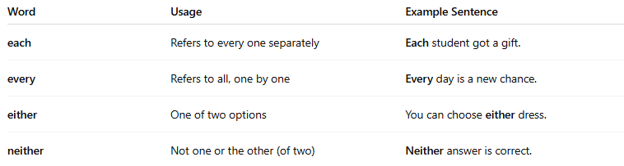
Word | Usage | Example Sentence
each | Refers to every one separately | Each student got a gift.
every | Refers to all, one by one | Every day is a new chance.
either | One of two options | You can choose either dress.
neither | Not one or the other (of two) | Neither answer is correct.

📚 Examples in Sentences
# Source: AI Source: Provided by: [Data Path: Persons Table -> ID Column: 1, Name_En Column: Motasem Essam] -> From: [Chatgpt (GPT-4-turbo)] on [7/27/2025]
- Each child received a balloon.
- Every room has a window.
- Either option works for me.
- Neither candidate won the vote.

🧠 Key Points
# Source: AI Source: Provided by: [Data Path: Persons Table -> ID Column: 1, Name_En Column: Motasem Essam] -> From: [Chatgpt (GPT-4-turbo)] on [7/27/2025]
- Always used before a noun.
- They refer to individual items within a group, not the group as a whole.
- Do not confuse them with distributive pronouns (which stand alone).

⚖️ Compare:
# Source: AI Source: Provided by: [Data Path: Persons Table -> ID Column: 1, Name_En Column: Motasem Essam] -> From: [Chatgpt (GPT-4-turbo)] on [7/27/2025]
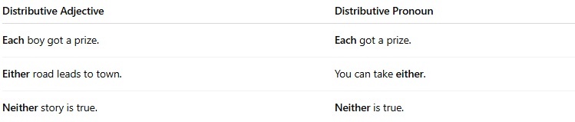
Distributive Adjective | Distributive Pronoun
Each boy got a prize. | Each got a prize.
Either road leads to town. | You can take either.
Neither story is true. | Neither is true.

Distributive Adjective vs. Distributive Pronoun
# Source: AI Source: Provided by: [Data Path: Persons Table -> ID Column: 1, Name_En Column: Motasem Essam] -> From: [Chatgpt (GPT-4-turbo)] on [7/27/2025]
Both distributive adjectives and distributive pronouns refer to individual items or persons in a group.
The key difference is whether they come before a noun (adjective) or replace a noun (pronoun).

✅ Distributive Adjective
# Source: AI Source: Provided by: [Data Path: Persons Table -> ID Column: 1, Name_En Column: Motasem Essam] -> From: [Chatgpt (GPT-4-turbo)] on [7/27/2025]
- Modifies a noun
- Always comes before a noun
- Describes individuals in a group
Examples:
- Each student got a prize.
- Every book is interesting.
- Either option is fine.
- Neither answer is correct.
🔸 “Each,” “every,” “either,” “neither” describe nouns (student, book, option, answer).

✅ Distributive Pronoun
# Source: AI Source: Provided by: [Data Path: Persons Table -> ID Column: 1, Name_En Column: Motasem Essam] -> From: [Chatgpt (GPT-4-turbo)] on [7/27/2025]
- Replaces a noun
- Stands alone in the sentence
- Refers to individual members without a following noun
Examples:
- Each got a prize.
- Either will do.
- Neither is acceptable.
🔸 The word stands in place of a noun (e.g., Each student → Each).

📊 Comparison Table
# Source: AI Source: Provided by: [Data Path: Persons Table -> ID Column: 1, Name_En Column: Motasem Essam] -> From: [Chatgpt (GPT-4-turbo)] on [7/27/2025]
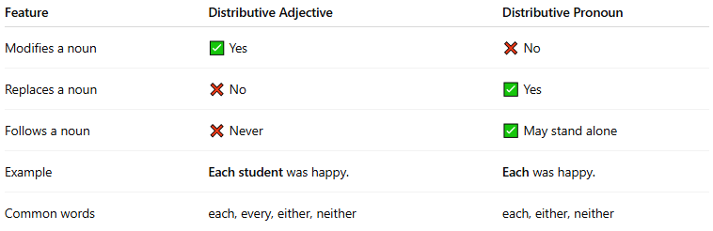

Feature | Distributive Adjective | Distributive Pronoun
Modifies a noun | ✅ Yes | ❌ No
Replaces a noun | ❌ No | ✅ Yes
Follows a noun | ❌ Never | ✅ May stand alone
Example | Each student was happy. | Each was happy.
Common words | each, every, either, neither | each, either, neither

